Thylia Watson
Ugo Achara
Samuel Ibikunle
MSBA 620

- Population = 1
Data = categorical
Parameter = π
-> One sample z-test for proportion with given value

π is the proportion of households that have their energy generated only from electricity

At 95% confidence level, the point estimate for households that have their energy generated only from electricity 0.292 +/- 0.04

- Population = 2
Data = numerical
Parameter = µ
Independent ? No
-> two sample t-text using match pair analysis

For T-test
H₀ : µ₁ = µ₂
H₁ : µ₁ ≠ µ₂

µ₁ = annual electricity cost
µ₂ = annual water cost

t-Test: Two-Sample Assuming Unequal Variances
 | Difference | Null
Mean | 1065.94604 | 0 | mean diff | 1065.946
Variance | 1024387.368 | 0 | stderr | 45.26339
Observations | 500 | 2 | tcrit | 1.964729
Hypothesized Mean Difference | 0 |  | marerr | 88.93032
df | 499 |  | UCL | 1154.876
t Stat | 23.54984839 |  | LCL | 977.0157
P(T<=t) one-tail | 2.56552E-83
t Critical one-tail | 1.647912984
P(T<=t) two-tail | 5.13104E-83 |  | Est of meandiff | 1066 +/- 89
t Critical two-tail | 1.964729391 |  | Conflvl | (977, 1155)
At a 95% confidence level, p-value 5.13 x 10⁻⁸³ > ⍺ = 0.05. Therefore, we do not reject H₀ and conclude that the annual electricity cost and annual water cost is consistent with one another.

- Population = 2
Data = numerical
Parameter = µ
Independent ? yes
-> two sample t-text using _________ variances
-> Run F test to determine equal or unequal variances

For F-test
H₀ : σ²₁ = σ²₂
H₁ : σ²₁ ≠ σ²₂

σ²₁ = Variances for household where energy is generated by both electricity and gas
σ²₂ = Variances for household where energy is generated by just electricity

F-Test Two-Sample for Variances
 | Water Cost | Variable 2
Mean | 1917.504944 | 1792.061781
Variance | 434921.0015 | 433672.0921
Observations | 354 | 146
df | 353 | 145
F | 1.002879847
P(F<=f) one-tail | 0.49953953
F Critical one-tail | 1.266750286

At a 95% confidence level, p-value 0.5 > ⍺/2 = 0.025. Therefore, we do not reject H₀ and run equal variance test

For T-test
H₀ : µ₁ = µ₂
H₁ : µ₁ ≠ µ₂

µ₁ = annual water cost for household where energy is generated by both electricity and gas

µ₂ = Annual water cost for household where energy is generated by just electricity

t-Test: Two-Sample Assuming Equal Variances
 | Variable 1 | Variable 2
Mean | 1917.504944 | 1792.061781 | meandiff | 125.4432
Variance | 434921.0015 | 433672.0921 | stderr | 64.83813
Observations | 354 | 146 | tcrit | 1.964739
Pooled Variance | 434557.3632 |  | marrerr | 127.39
Hypothesized Mean Difference | 0 |  | UCL | 252.8332
df | 498 |  | LCL | -1.94684
t Stat | 1.934712756
P(T<=t) one-tail | 0.026795772
t Critical one-tail | 1.647919139 |  | est of meandiff | 125 +/- 127
P(T<=t) two-tail | 0.053591545 |  | conflvl | (-2, 253)
t Critical two-tail | 1.964738983

At a 95% confidence level, p-value 0.053 > ⍺ = 0.05. Therefore, we do not reject H₀ and conclude that the annual water cost for household where energy is generated by both electricity and gas and Annual water cost for household where energy is generated by just electricity are consistent with one another.
- y = β₀ + β₁X
Y = energy cost
X = annual income

- Scatterplot shows a strong positive relationship between energy cost and annual income 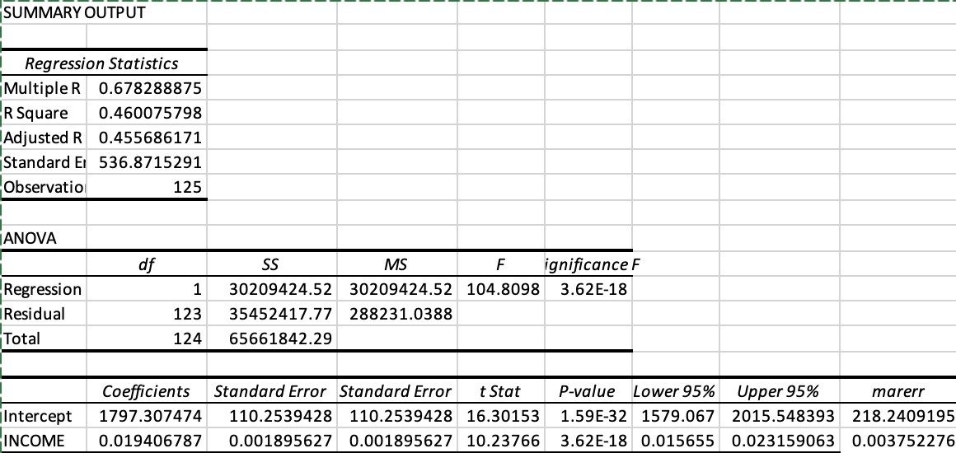
- At 95% confidence level, ANOVA table = 3.6 x 10⁻¹⁸ < α = 0.05. Therefore, we can conclude that we have a statistically significant model.
- With R² = 0.46, 46% of our variation in energy cost is explained by the model. The variable coefficient for energy cost is significant.
- y = 1797 + 0.019x
- Est of β₀ : 1797 +/- 218

  - Interpretation of β₀ We should expect energy cost to go up by 1797 +/- 218 if the annual income is zero

- Est of β₁ : 0.019 +/- 0.003
- Interpretation of β₁ : For every additional increase in annual income, there is a 0.019 +/- 0.003 decrease in energy cost
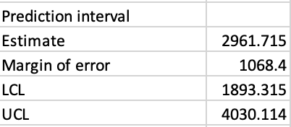
- For a household in Hawesville with an annual income of $60,000, The annual energy cost will be 2962 +/- 1068

- Repeating the same process for households in Whitesville, there is no linear relationship between annual income and annual energy cost. Additionally the p-value of households in Whitesville is 0.3 > α = 0.05, therefore we can conclude that we do not have a statistically significant model.

